|  |
| --- |
| **NAVRACHANA UNIVERSITY** |
|  |
|  |
| **SCHOOL OF ENGINEERING & TECHNOLOGY** |
|  |
| **BTech-IT** |
|  |
|  |
| **PROJECT**  **REPORT** |
|  |
|  |
| **Final Year BTech-IT** |
|  |
| **SEMESTER: 7** |
|  |
|  |
| **COURSE:IN-HOUSE PROJECT** |
|  |
| **COURSE CODE: IT413** |
|  |
| **ACADEMIC YEAR: 2022-23** |
|  |
|  |
|  |
|  |

|  |
| --- |
| **NAVRACHANA UNIVERSITY** |
|  |
|  |
| **SCHOOL OF ENGINEERING & TECHNOLOGY** |
|  |
| **BTech-IT** |
|  |
|  |
| **GREEN LEAF** |
|  |
| *Submitted in partial fulfilment of Degree of* |
| **BTech-Information Technology** |
|  |
|  |
| **COURSE: IN HOUSE PROJECT** |
|  |
| **COURSE CODE: IT413** |
|  |
| **ACADEMIC YEAR: 2022-23 SEMESTER: AUTUMN** |
|  |
| **Submitted by: Vijay Vaghela & Gautam Shah.** |
| **TEAM ID:23** |
|  |
|  |
| **MEMBER IDs & NAMES: 19125059-Vijay Vaghela,**  **19125060- Gautam Shah.** |
|  |

**CERTIFICATE**



*This is to certify that* ***Vijay Vaghela & Gautam Shah*** *having student ID:* ***19125059 & 19125060*** *associated with BTech-IT program at Navrachana University, has successfully completed working on project entitled:* ***Green Leaf*** *and accomplished the requirements of course* ***In-House Project*** *having course code* ***(IT-413)*** *for duration from July 2022 to December 2022 within the institute premises.*

|  |  |
| --- | --- |
| **Signature:** | **Signature** |
| **(Internship Co-ordinator)**  **Priya Vadgama** | **(Program Chair)**  Mr. GauravkumarsinghGharwar |
|  | **Signature** |
|  | **(School Head)**  ***Dr. Ashish Jani*** |

**TABLE OF CONTENTS**

|  |  |  |
| --- | --- | --- |
| **SR. NO.** | **TOPIC** | **PAGE NO.** |
| **1** | **Project Report Template** | **1** |
| **2** | **Project Title Template** | **2** |
| **3** | **Certificate Template** | **3** |
| **4** | **List of topic table** | **4** |
| **5** | **List of figures** | **5** |
| **6** | **List OfAbbrevation** | **6** |
| **7** | **Abstract** | **7** |
| **8** | **Chapter1** | **8** |
| **9** | **Chapter 2** | **9** |
| **10** | **Chapter3** | **10** |
| **11** | **Chapter4** | **11** |
| **12** | **Chapter5** | **17** |
| **13** | **Chapter6** | **24** |
| **14** | **Conclusion and Future Scope** | **25** |
| **15** | **Bibliography and References** | **26** |

**LIST OF FIGURES**

**<example is given>**

|  |  |  |
| --- | --- | --- |
| **Figure No.** | **Caption** | **Page Number** |
| **1** | **E.R. Diagram** | **12** |
| **2** | **TABLE SCHEMA(Admin table)** | **13** |
| **3** | **Object Diagram** | **13** |
| **5** | **Use case Diagram** | **14** |
| **6** | **Sequence Diagram** | **14** |
| **7** | **Activity Diagram** | **15** |
| **8** | **State Diagram** | **15** |
| **9** | **wireframe** | **16** |
| **10** | **home Page** | **21** |
| **11** | **Product page** | **21** |
| **12** | **policy Page** | **22** |
| **13** | **About us Page** | **22** |
| **14** | **Contact Us Page** | **22** |
| **15** | **Carrier Page** | **23** |
| **16** | **Owner Page** | **23** |

**LIST OF ABBREVIATIONS**

**<example is given below>**

|  |  |  |
| --- | --- | --- |
| **Sr. No.** | **Abbreviations** | **Expansion** |
|  | IoT | Internet of Things |
|  | GIoT | Green Internet of Things |
|  | M-SMDM | Model of Security Measures using the green internet of things with cloud integrated Data Management |
|  | C-AMBC | Cognitive Ambient Backscatter Communication |
|  | SNR | Signal to Noise Ratio |
|  | MPTCP | Multipath Transmission Control Protocol |
|  | EBDS | Energy-Efficient and Big-data based Secure |
|  | DDoS | Distributed Denial of Service |
|  | UCI | University of California Irvine |
|  | ECC | Elliptic Curve Cryptography |
|  | RC | Rivest Cipher |
|  | SHA | Secure Hash Algorithm |
|  | MiM | Man-in-the-Middle |
|  | OTA | Over The Air |
|  | MQTT | Message Queuing Telemetry Transport |
|  | CoAP | Constrained Application Protocol |
|  | IIoT | Industrial Internet of Things |
|  | CLAEKS | Certificateless Authenticated Encryption with Keyword Search |

**ABSTRACT**

We will be using a tool that is user friendly and helps us to design and develop a ecommerce website through that we can solve a problem of Tiffin service in an area or locality.

Problem was to find a Tiffin service man for students and Bachelors. To this problem we have added a solution by making a E-commerce website that will help student and Bachelors to book their orders.

**CHAPTER 1. INTRODUCTION**

* 1. **System Name: GREEN LEAF**
  2. **System Description:**

We will be using a tool that is user friendly and helps us to design and develop a ecommerce website through that we can solve a problem of Tiffin service in an area or locality.

Problem was to find a Tiffin service man for students and Bachelors. To this problem we have added a solution by making a E-commerce website that will help student and Bachelors to book their orders.

* 1. **Aim of the System:**

Problem was to find a Tiffin service man for students and Bachelors. To this problem we have added a solution by making a E-commerce website that will help student and Bachelors to book their orders.

* 1. **Literature Survey:**

1. Zomato

2. SpiceBox

3. My Dabba Food

**Zomato:** Zomato initially named as Foodie bay was started in 2008 by Mr. Deepinder Goyal. It is a restaurant searching platform providing in-depth details with autonomous reviews and ratings. Foodie bay, the initial name was changed to Zomato in November 2010 to increase their reach among people. • To make homemade Tiffin easily available to users and tracking the vendor for delivery. • Useful for college students, hostel residents and employees. As the application will provide a platform for ordering a home-made meal on the go.

**SpiceBox:** Name– SpiceBox Location – Mumbai and Navi-Mumbai. Working – This program provides vegetarian and vegetarian diets to users (customers). Provides other veg / non-veg diet dates. SpiceBox also offers a discounted price, if one offers tiffin orders for food for a period of days Limits – 1. Do not give different foods every week. 2. It is not easy to use.

**My Dabba Food Name** - My Dabba Food Location - Provided in various locations in India. Working - This website provides Tiffin services in various locations in India. The organization's plan is to provide a Tiffin Centre location for local users / markers. It shows the location of the Tiffin Centre near his place. Benefits - A customer (Tiffin supplier) can easily grow his business in his area.

**Business Drivers** Thus the online retail business can deliver more advanced services faster because of three main factors: scalability, intricacy, and velocity – which are crucial key drivers of ecommerce.

**Business model** - An e-commerce business model is how your e-commerce business is structured conceptually in order to reach customers and drive sales. There are several types of e-commerce business models that enable different kinds of companies to position themselves in the market and reach their customers in an effective way.

**Scope and Constraints of the System:**

We will be using a tool that is user friendly and helps us to design and develop a ecommerce website through that we can solve a problem of Tiffin service in an area or locality.

Problem was to find a Tiffin service man for students and Bachelors. To this problem we have added a solution by making a E-commerce website that will help student and Bachelors to book their orders.

**CHAPTER 2. REQUIREMENT ANALYSIS AND ELICITATION**

# Functional and System Requirements

#### Functional Requirements:

* + Mobile-friendliness.
  + Unique, recognizable design.
  + Shipping & payment systems integration.
  + Live chat. System Requirements:
  + Fast, stable & secure web hosting.
  + Highly-responsive mobile site.
  + User-friendly web design.
  + Fast checkout process.

# Technical requirements

* + Fast, stable & secure web hosting. ...
  + Highly-responsive mobile site. ...
  + User-friendly web design. ...
  + Robust operation systems. ...
  + Fast checkout process. ...
  + Transparent brand information pages. ...
  + SEO-friendly web pages. ...
  + Smooth sales channels integration.

**CHAPTER 3. USER INFORMATION**

The model of tiffin service business is quite simple. You serve fresh and healthy home-made food to people who are living away from their homes. Typically, your customers will be young working professionals or students.The basic requirements for a tiffin service business are different types of equipment, tiffin boxes, kitchen utilities, culinary skills, a good menu and a food and safety licence.

**CHAPTER 4. SYSTEM MODELLING**

**4.1. E-R DIAGRAM:**

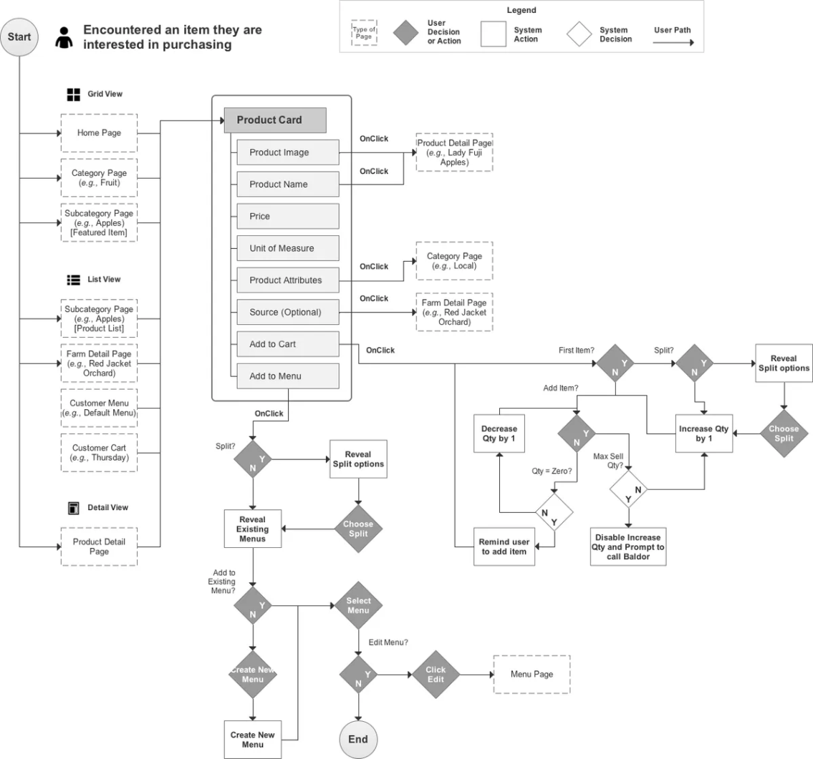

**4.2. TABLE SCHEMA**

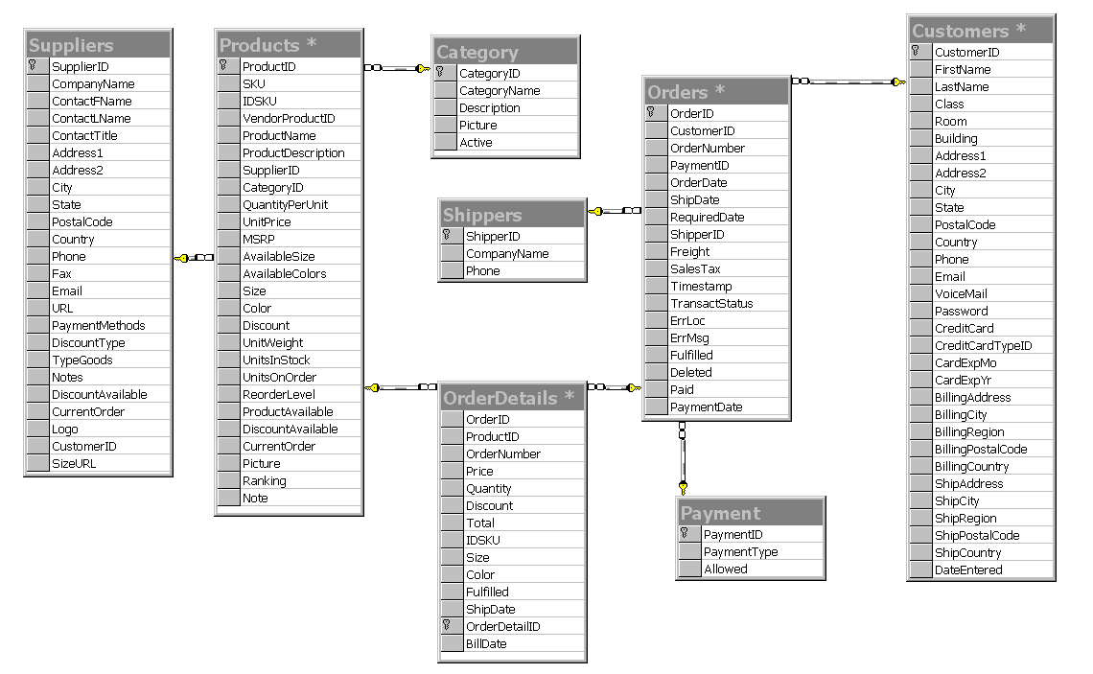

**4.3. OBJECT DIAGRAM**

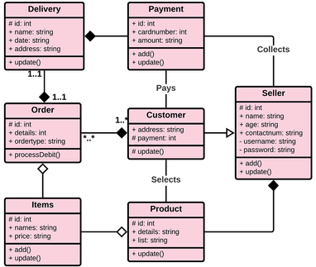

**4.4. USE CASE DIAGRAM:**

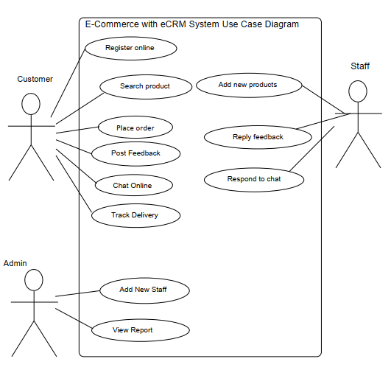

**4.5. SEQUENCE DIAGRAM:**

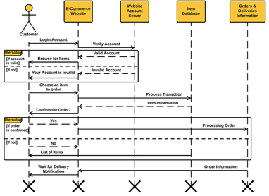

**4.6. ACTIVITY DIAGRAM**

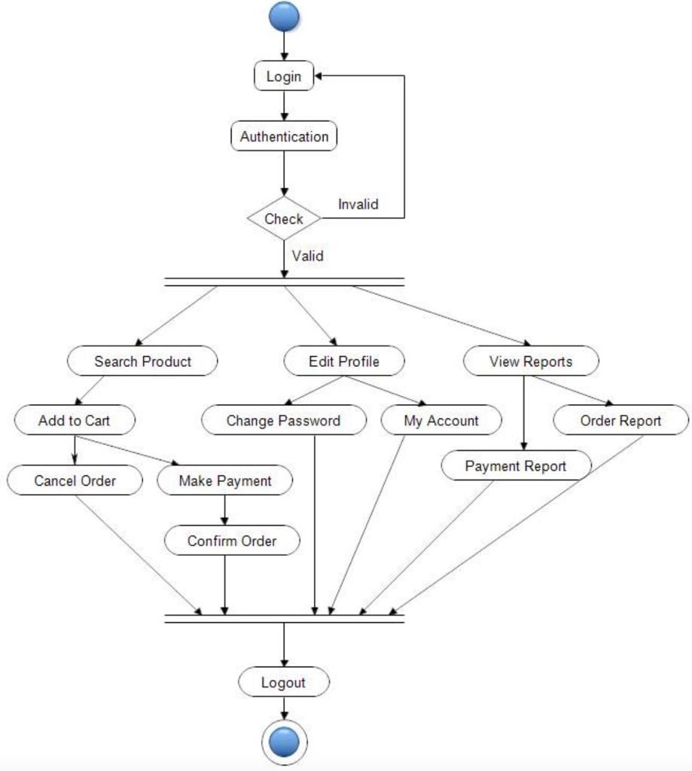

**4.7.STATE DIAGRAM (FINITE STATE MACHINE DIAGRAM)**

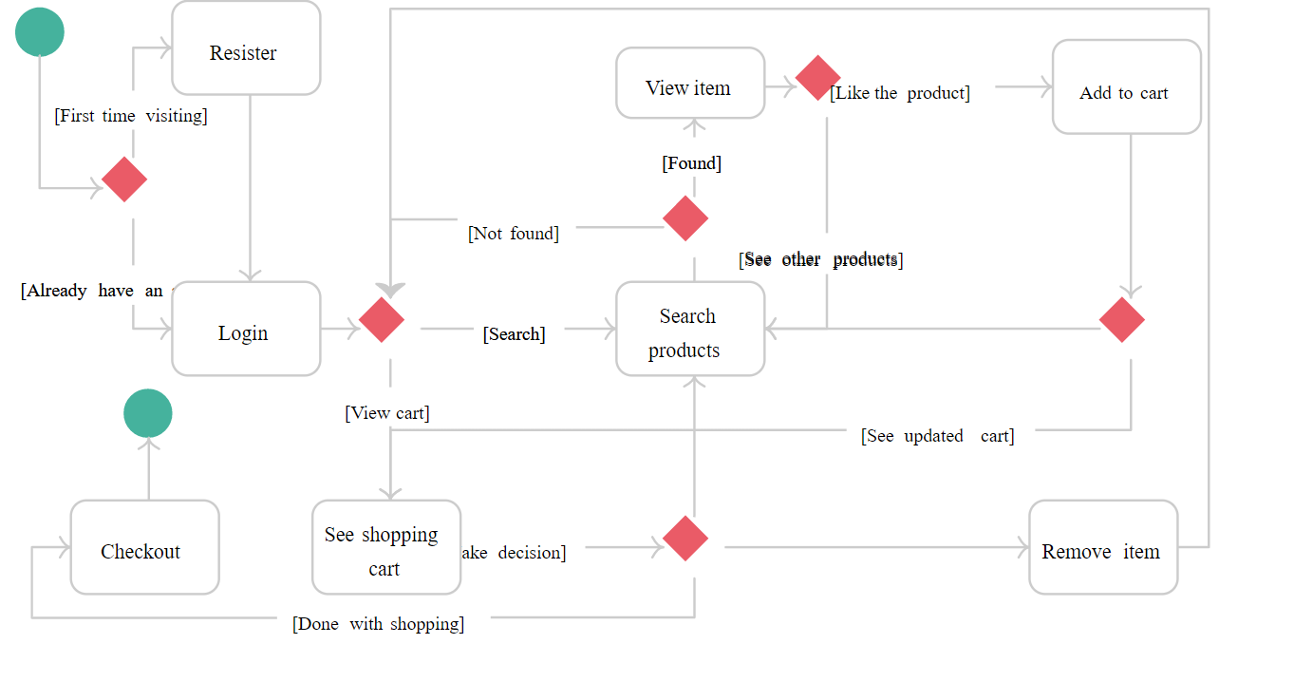

**4.8. SCHEMATIC/ CIRCUIT DIAGRAM/WIREFRAMES:**

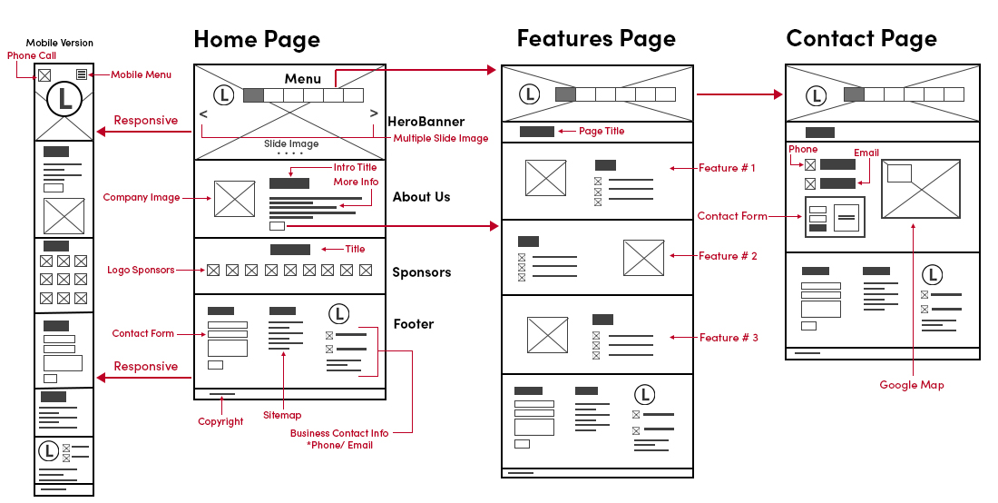

**CHAPTER 5. TESTING AND IMPLEMENTATION**

**TASK 1: Identify Testing Techniques:**

***Typical test types.***

* Functional Testing
* Usability Testing
* Security Testing
* Performance Testing

**TASK 2: Design Test Cases:**

Enlist the test cases that will be used for testing the system’s reliability. There should be at least 15 test cases with scenarios or explanations related to them.

### #1) Homepage

Homepages of retail sites are busy. They have a lot going on. But almost all of them have a Hero Image:

This is the kind of the clickable image (a slideshow of sorts) that occupies the majority of the page.

**The following are a few things to test:**

* Is it going to auto scroll?
* If yes, at what interval will the image be refreshed?
* When the user hovers over it, is it still going to scroll to the next one?
* Can it be hovered on?
* Can it be clicked on?
* If yes, is it taking you to the right page and right deal?
* Is it loading along with the rest of the page or loads last in comparison to the other elements on the page?
* Can the rest of the content be viewed?
* Does it render the same way in different browsers and different screen resolutions?

### #3) Product Details Page

Once a user finds a product either through search or by browsing or by clicking on it from the homepage, the user will be taken to the product information page.

**Check:**

* Image or images of the product
* Price of the product
* Product specifications
* Reviews
* Check out options
* Delivery options
* Shipping information
* In-stock/Out of stock
* Multiple color or variations options
* Breadcrumb navigation for the categories (highlighted in Red below). If navigation such as that is displayed, make sure every element of it is functional.

### #4) Shopping Cart

This is the penultimate stage before the user commits to the purchase.

**Test the following:**

* Add items to the cart and continue shopping
* If the user adds the same item to the cart while continuing to shop, the item count in the shopping cart should get incremented
* All items and their totals should be displayed in the cart
* Taxes as per location should be applied
* A user can add more items to the cart- total should reflect the same
* Update the contents added to the cart- total should reflect that too
* Remove items from the cart
* Proceed to checkout
* Calculate Shipping costs with [different shipping options](https://www.softwaretestinghelp.com/best-cheapest-shipping-companies/)
* Apply coupons
* Don’t check out, close the site, and come back later. The site should retain the items in the cart

### #5) Payments

* Check different payment options
* If allowing check out as Guest, simply finish the purchase and provide an option to register at the end
* Returning customers – Login to check out
* User sign up
* If storing customer Credit card or any other financial information, perform security testing around this to make sure it is secure.(PCI compliance is a must)
* If the user is signed up for a long time, make sure the session is timed out or not. Every site has a different threshold. For some, it is 10 minutes. For some, it might be different.
* Emails/Text confirmation with the order number generated

### #6) Categories/Featured Products/Related or Recommended Products

The most popular FAQ I get from E-commerce testers is: Do I have to test every category/every product?

The answer is NO.

If you are a returning customer you will be shown some recommended products on the home page or in your shopping cart.

Featured products also change almost every day.

Since these are dynamic elements, the best way to test these parts of the application is to test the algorithm based on which these sections are populated.

Check your Data mining/BI systems and check from the backend the queries that populate these sections.

### #7) After-Order Tests

**Check:**

* Change the Order
* Cancel the Order
* Track the Order
* Returns

### #8) Other Tests

* Login
* FAQs
* Contact Us page
* Customer Service page etc.

### Challenges Automating E-commerce Website

To remain on Safer Edge and deliver the desired results to the client you need to shift the focus on quality and performance of your E-commerce website while shrinking timeline as much as possible

In general Automation Testing starts by selecting right test automation framework which directly impacts on the result of the test automation project. The framework must include the test scripts and the scenarios of various automated processes.

Based on the framework, the testers can easily execute the tests and obtain relevant results by generating test reports. But selecting right tool to automate E-commerce Website depends on many key parameters.  It is always important to compare the available tools based on key parameters like features, performance, extensibility, licensing cost, maintenance cost, and Training and support.

You must take [advantage of many open source test automation tools](https://jackmartin6.wordpress.com/2015/12/02/a-look-into-the-future-of-test-automation-tools/) to automate more testing efforts without investing additional funds.

**#1)** E-commerce websites are much entangled in nature, automating each action is not possible because we cannot assume the nature of the customer.

**#2)** Continuous changes for e-commerce demands Regression so run regression test suit every day to keep track the effects of change.

**#3)** Always go with Automating Integration type of scenarios that should cover from selecting a link on home page till checkout and [payment gateway page.](https://www.softwaretestinghelp.com/best-payment-gateway/) Hereby, you can at least cover maximum user experience with E-commerce Website, so that adequate testing can be achieved by automating regression cycle.

**#4)** Never waste time automating on the unstable application. A simple change will affect your whole test suits and you have to recreate it.

**#5)** Homepage of E-commerce Website is very important and contents many information and 1000 of links associated with each product and these links grow up every day as new offers or product is added to a page. So before proceeding to regression testing its best to verify every link in page by using HTTP status code.

**#6)** When you are executing test scripts on a different browser at the same time. If a product is added to shopping cart or removed that information should be reflected in other browsers too.

**#7)** When you running test parallel this will obviously fail your script in such scenario you have to periodically refresh your page to retain cart information. In real-time you may come across this scenario such as a user may sometimes use mobile e-commerce app and also a mobile e-commerce web application.

**#8)** Don’t neglect to verify each product details and pricing details whether it is 10 products or 1000 products it should be as per the seller requirement. This is the phase where you can make or break a customer slight mistake will lead to a big loss.

**#9)** Create yourself a lot of interrupted scenarios that usually user come across design your script very robust so that your script affords it and still run and pass the script.

***For Example,*** you stored all the card information and clicked on submit due to low charge or network issue application stuck. In this case, a user is notified about his transaction status through email and message to phone you should validate this email or message in a test script.

**#10)** Web element of E-commerce website keeps changing so always Create manual xpath. Some Web Elements attributes will be the same so there will be no unique way of distinguishing in such scenario use contains() method of xpaths or scroll into view.

**#11)** Automate [Accessibility Testing](https://www.softwaretestinghelp.com/what-is-web-accessibility-testing/) by keyboard actions without using mouse action you definitely will come across some of the problems and fix it. This plays a significant role in user interface testing.

**#12)** Tester should be carefully designed the scenario and add initiate checkpoint and insert login script whenever it is required.

**#13)** Maintain different scripts for a different mode of payment to avoid confusion. Check if what happens if an order is canceling after payment.

**#14)** Performance testing in other hand plays a very crucial role. The factors you need to test here request per second, Transaction Per minute, Execution per click, a Response time of page load, duration of the task, Length of time between click and page display and DNS lookup.

**#15)** Security Testing is where customer trust is gained on which e-commerce is built so here you have to spend a lot of time testing on DENIAL OF SERVICE ATTACK, User Account security, Data confidentiality, content security, credit card security, disable non-essential services.SSL Certificate Validation.

**#16)** Automating  Localization testing is very challenging in e-commerce because of Compliance with accessibility standards to support multi-lingual markets and business regions.

|  |  |  |  |  |
| --- | --- | --- | --- | --- |
| **Sr. No.** | **Test Case** | **Working(√) / Not Working (X)** | **Reason for Not Working** | **Corrective Measures** |
|  | Home Page |  | - | - |
|  | Product Page | ✓ | - | - |
|  | Book Product | ✓ | - | - |
|  | Owner | ✓ | - | - |
|  | About | ✓ | - | - |
|  | FAQ | ✓ | - | - |
|  | Store Policy | ✓ |  |  |
|  | Contact us | ✓ | - | - |
|  | Shipping and return | ✓ | - | - |
|  | Add to cart | ✓ | - | - |
|  | Payment | ✓ | - | - |

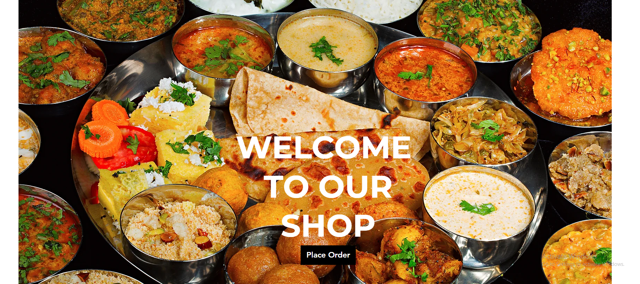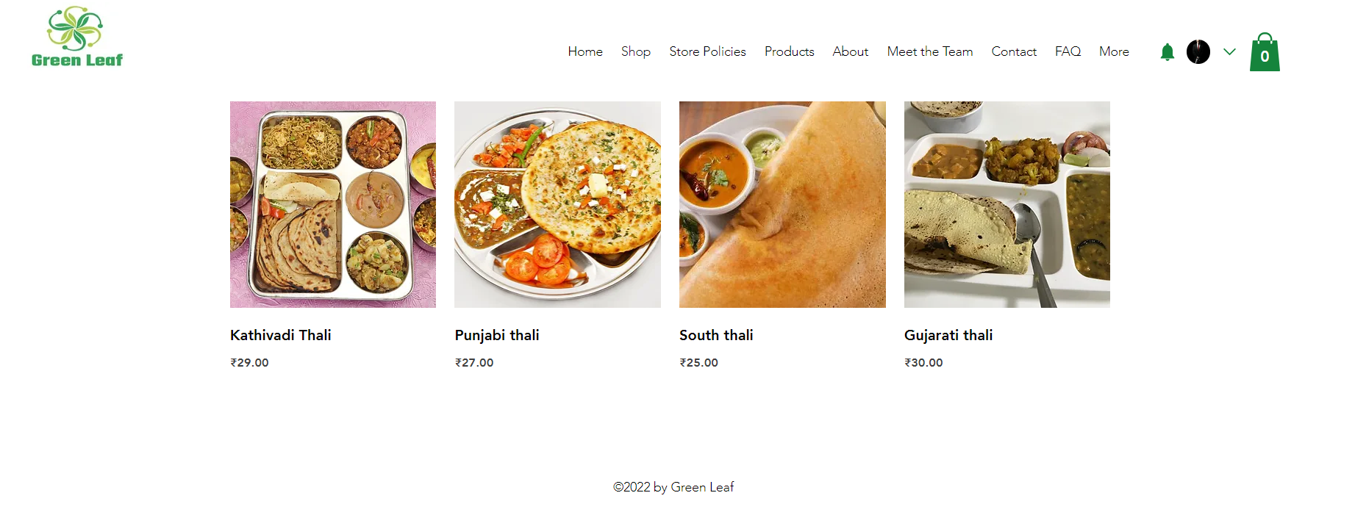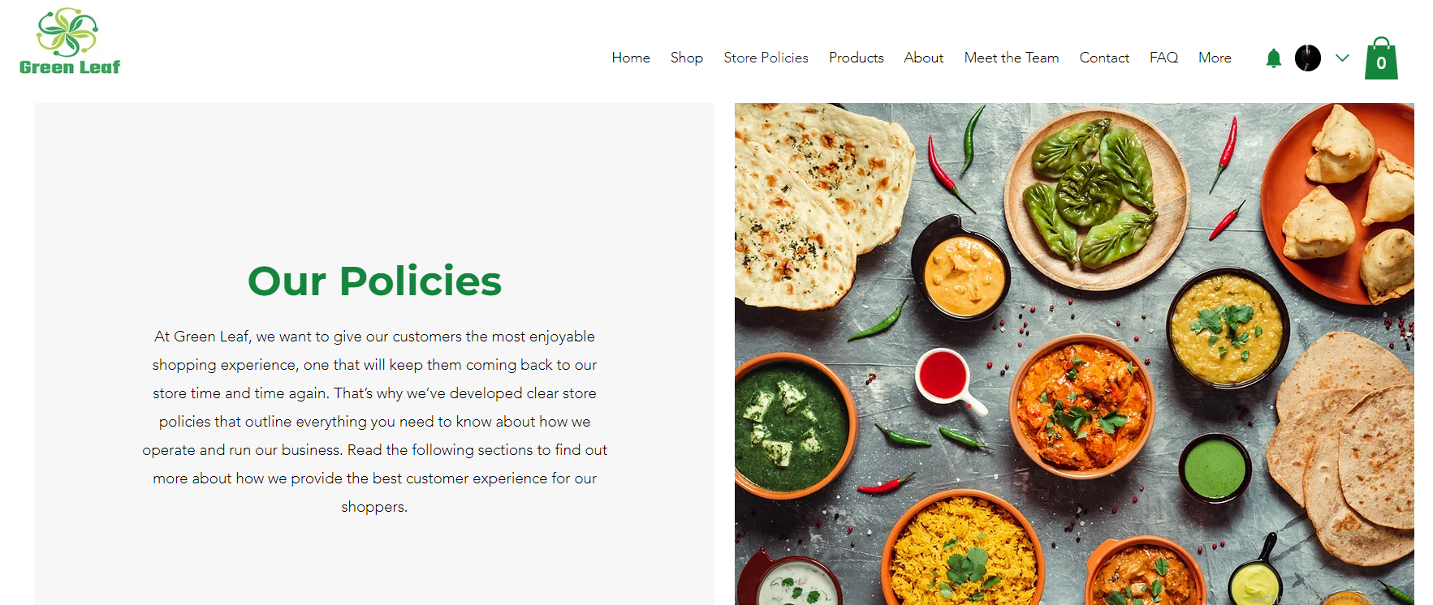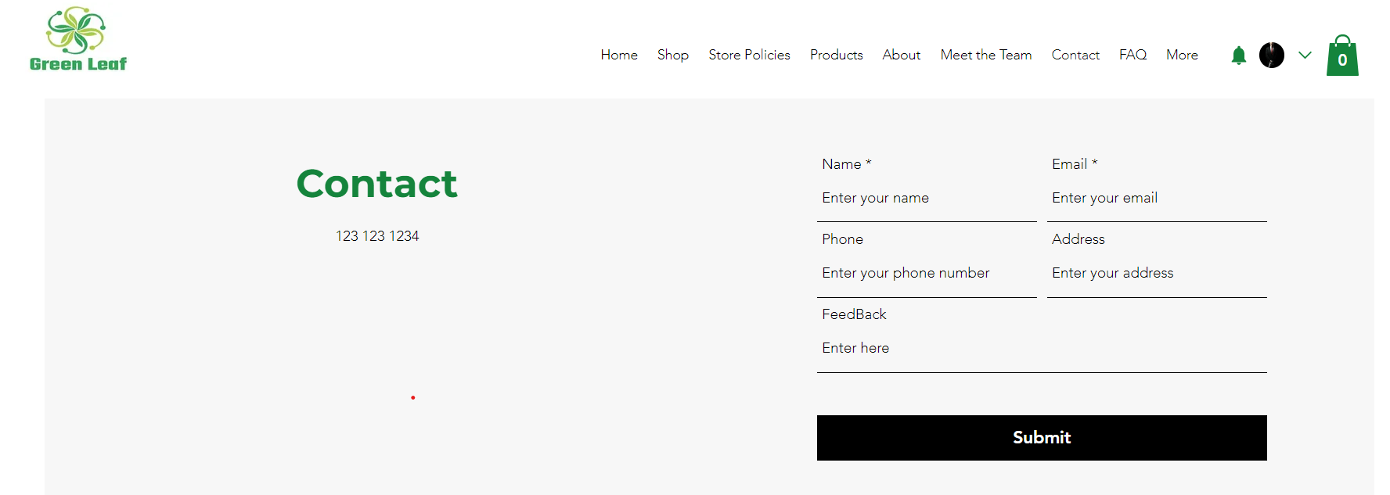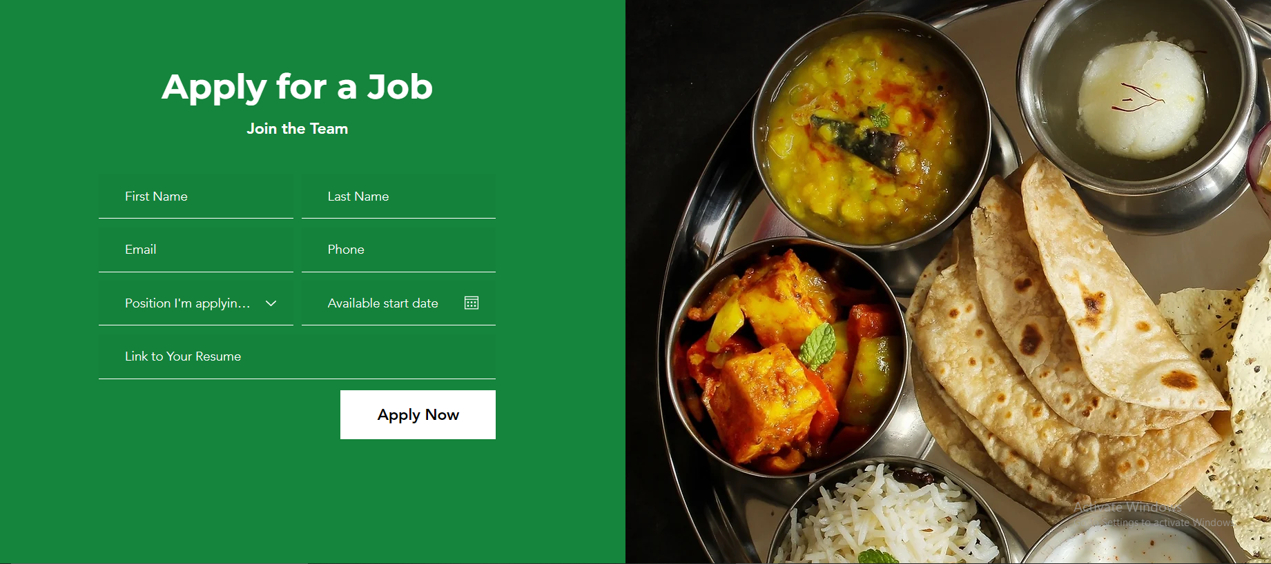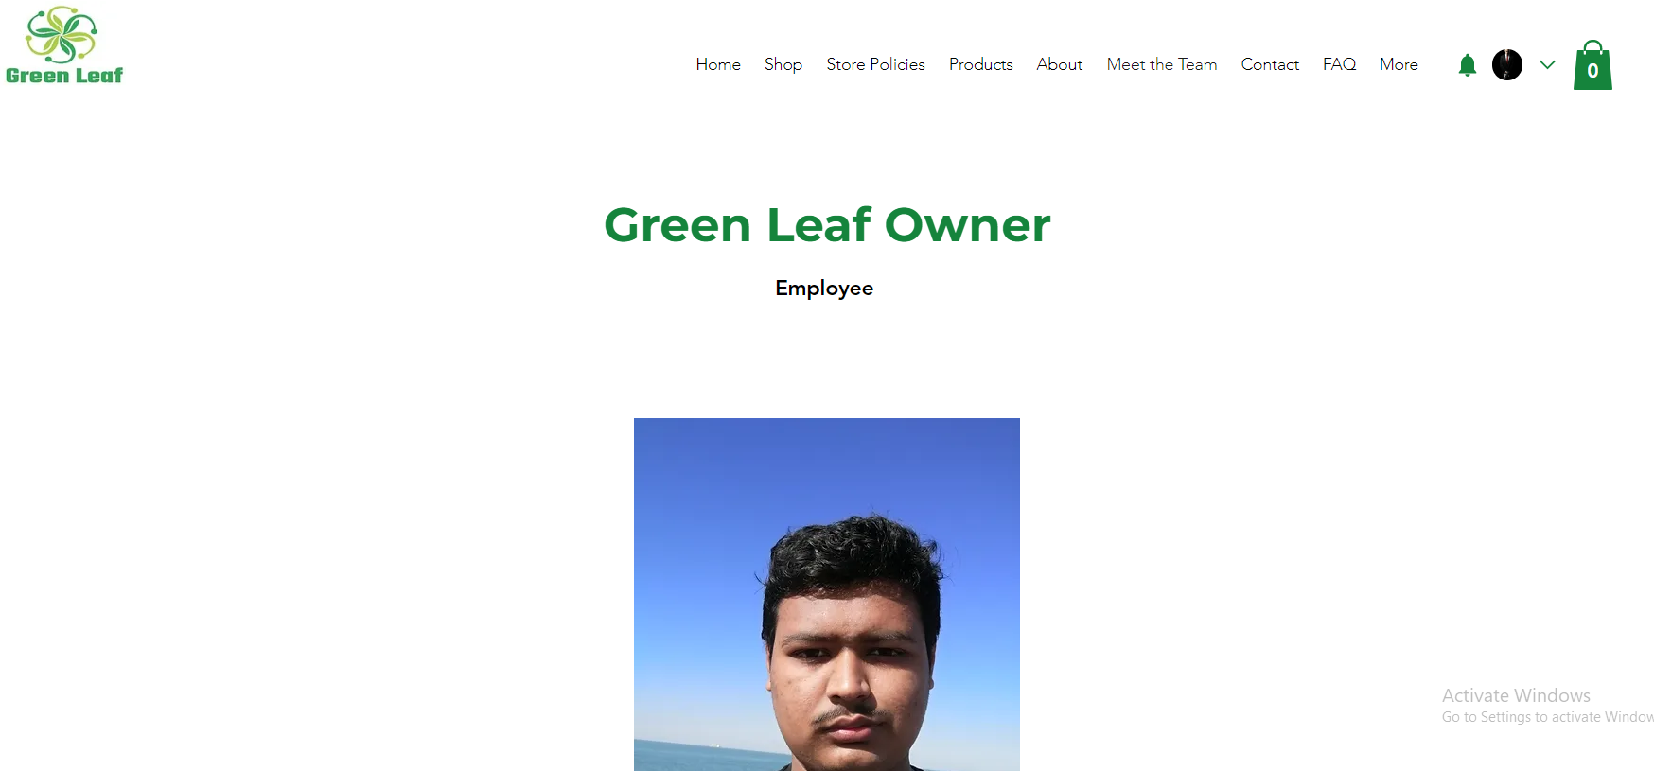

**CHAPTER 6. REVISION HISTORY**

**Revision History:**

|  |  |  |
| --- | --- | --- |
| **Review No.** | **Suggestions** | **Changes incorporated** |
| 1 | Think about business models.  Think about mobile app along with website. | Started implemented the website development and thinking to do application for the same. |
| 2 | Rework on context diagram.  Add system boundary in use-case.  Rework on ER Diagram and add primary key to it. | Done the changes and shown to Gaurav Sir and Sir have approved the changes made by us. |
| 3 | Write it in terms of tangible outcomes. | We have done necessary changes. |
|  |  |  |

**CONCLUSION**

To conclude my statement, I would say finding a Tiffin man was a headache to batchers and students, this issue was resolved by providing a solution by making website for booking.

**FUTURE SCOPE**

Here we can continue this website by enhancing the system by add Application to it and we can add multiple vendors to it and this helps the user to get his needs fulfil easily.

**BIBLIOGRAPHY & REFERENCES**

1. <https://www.figma.com>
2. <https://startuptalky.com/ecommerce-website-backend-development/>
3. <https://try.airtable.com/database?utm_source=google&utm_medium=paidsearch&utm_extra5=kwd-16729721&utm_extra2=17337519559&utm_extra10=138052347318&creative=612096827447&utm_extra8=c&cx=row&utm_campaign=demand_nb_database_creator&utm_content=text&utm_term=database%20online&ds_e_utm_extra8=c&gclid=CjwKCAjw7p6aBhBiEiwA83fGuojvpJuNz_6-vTLXk_oUdXsaIW2h7ib8LbPlEw6KifX9XdPRFNdiTRoCinMQAvD_BwE&gclsrc=aw.ds&r=aHR0cHM6Ly93d3cuZ29vZ2xlLmNvbS8%3D>
4. <https://www.google.com/search?q=backend+database+implementation+for+ecommerce+website&rlz=1C1RXQR_enIN1026IN1026&oq=backend+database+implementation&aqs=chrome.1.69i57j33i160.2198j0j7&sourceid=chrome&ie=UTF-8>